**Cloud security**

1)Set inactive timeout to 15 mins

2)Enable Azure for Global Azure administrator

3)Disable app registration for users

4)Disable access to active directory

5)Disable account registration with linkdin

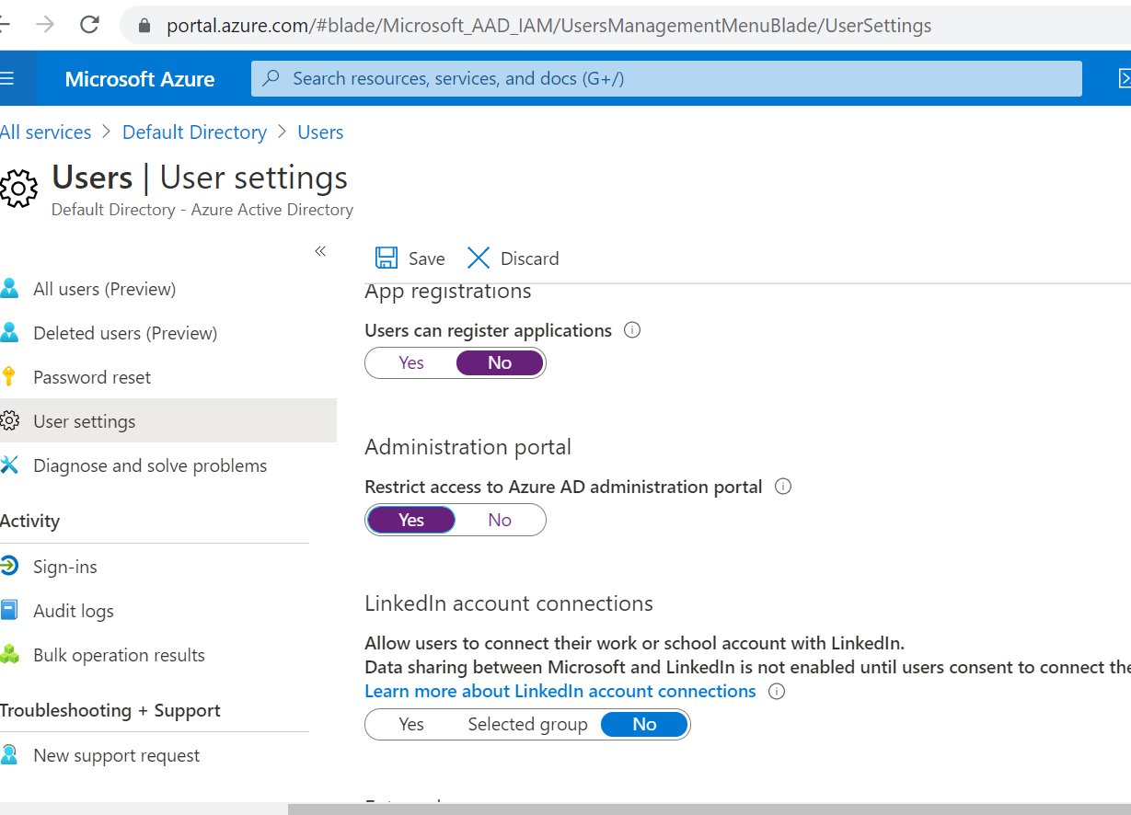

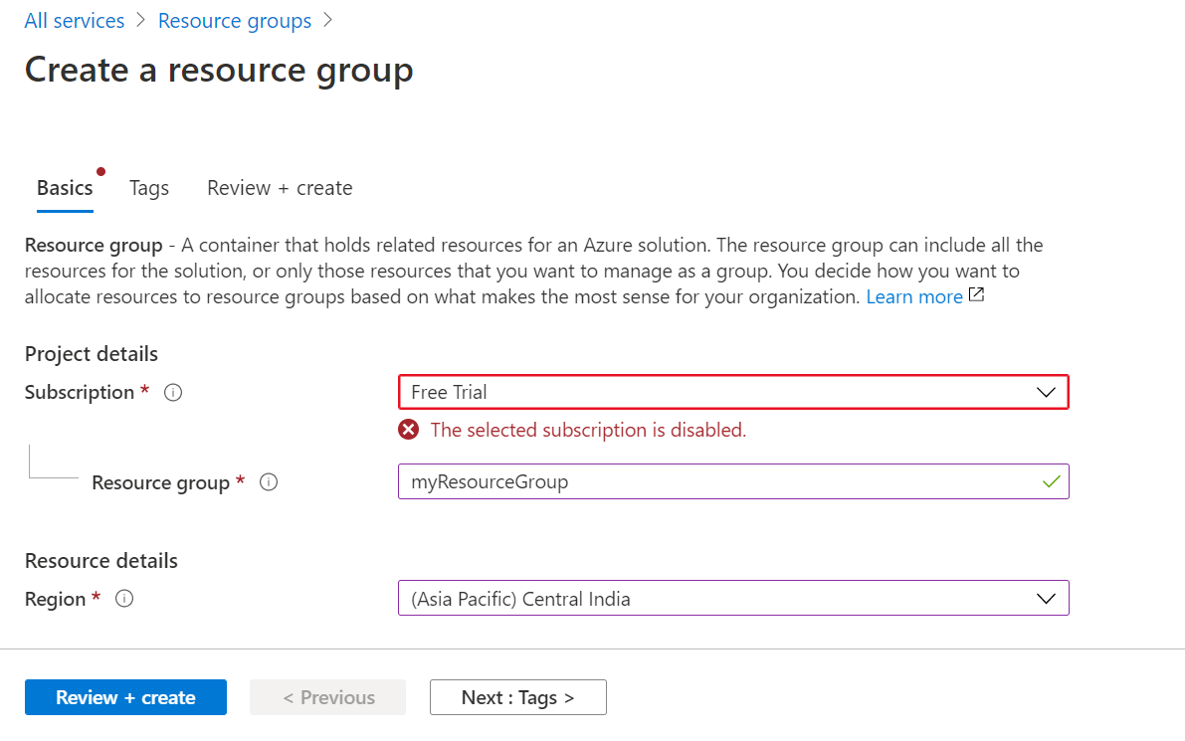

https://portal.azure.com/#blade/Microsoft_AAD_IAM/UsersManagementMenuBlade/MsGraphUsers